PROBLEM 60 –

CHESS

https://github.com/Priyansi/pythonPrograms/blob/master/chessGame.pgn

This Is the PGN file I used.

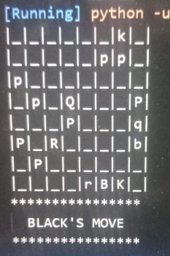

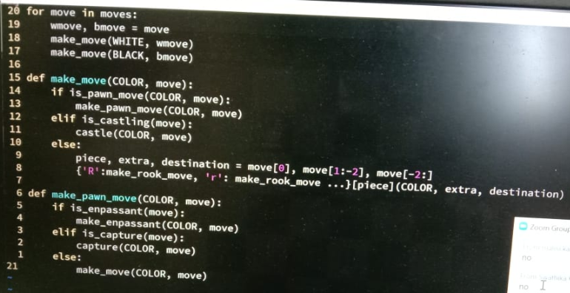

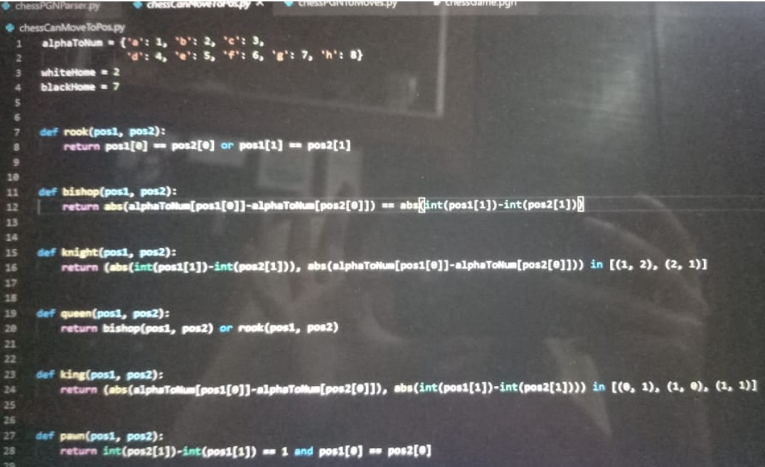

This is the code for when a piece can move to another location that Asokan made us write

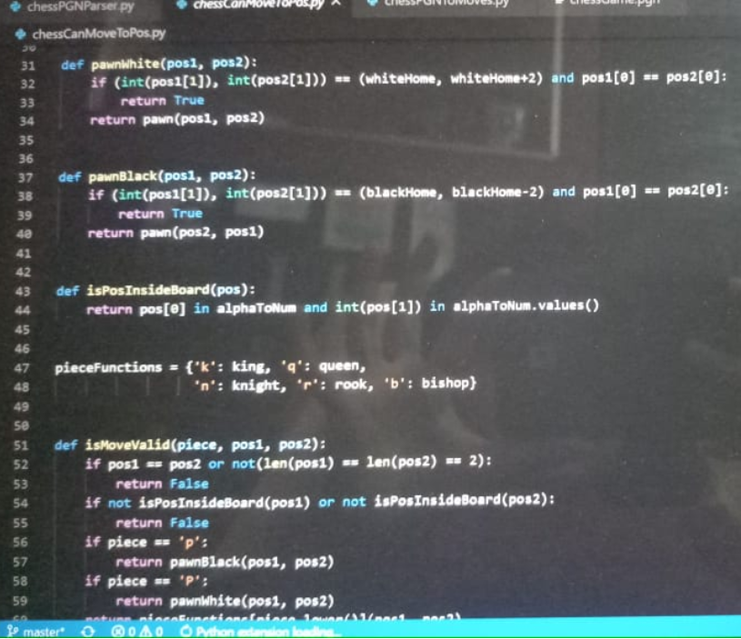

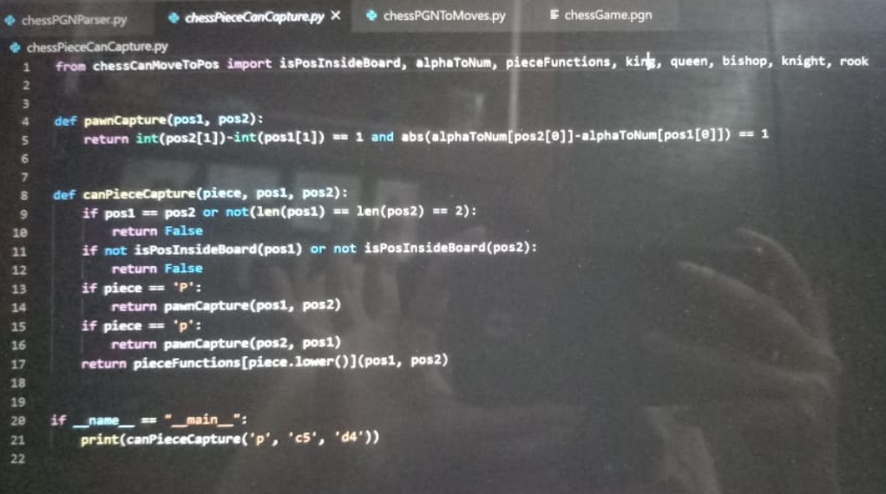

This code captures another piece

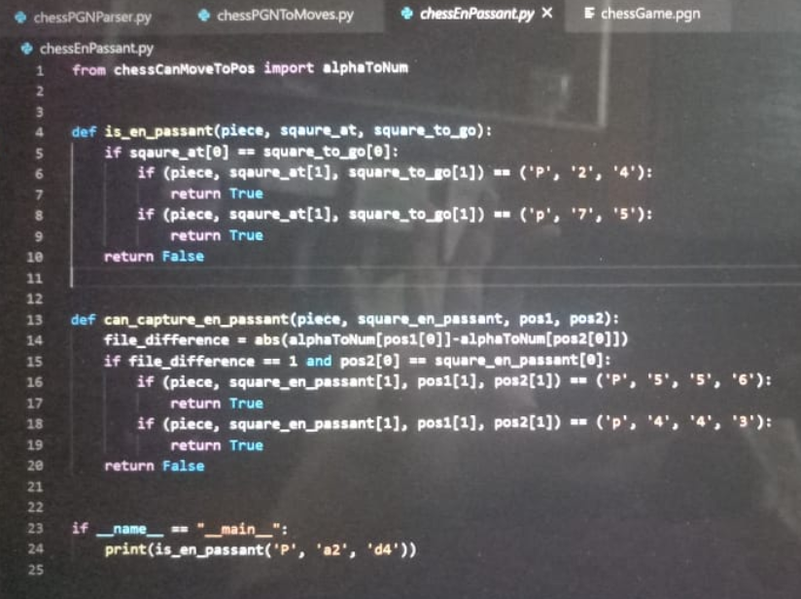

These are the two functions needed for en passant

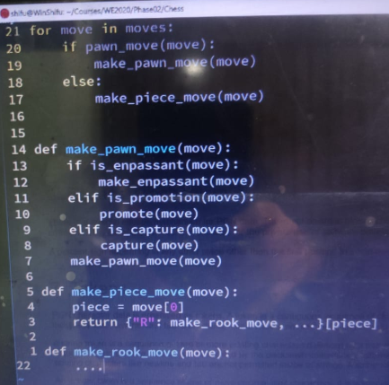 CODE TOM BE WRITTEN IN THIS STYLE

O-O is king side castling

O-O-O is queen side castling

[1:18 PM, 5/3/2020] Nimisha: You need to read the pgn file yaar

[1:18 PM, 5/3/2020] Nimisha: Update the board view and piece view

[1:18 PM, 5/3/2020] Nimisha: Then you need to return a fen notation

[1:18 PM, 5/3/2020] Nimisha: Of the result

[5:44 PM, 5/3/2020] Nimisha: We can copy paste in debian from outside ?

[5:44 PM, 5/3/2020] Nimisha: Right click

[5:44 PM, 5/3/2020] Nimisha: To paste

[5:44 PM, 5/3/2020] Nimisha: Use mouse to copy

[5:44 PM, 5/3/2020] Nimisha: Just right click to paste

[5:44 PM, 5/3/2020] Nimisha: Or you can enable paste with ctr shict v in the properties

[6:31 PM, 5/3/2020] Nimisha: We have pgn file right? And we're first representing the pieces on the board... Then we're checking the moves and making changes in the board accordingly

[7:09 PM, 5/3/2020] Nimisha: I guess we have to update the board view and piece view as per the moves

[7:09 PM, 5/3/2020] Nimisha: So checkmate honeke baad jo bacha wo display karna hai...just in FEN instead of PGN?

[7:29 PM, 5/3/2020] Nimisha: His code gives moves and now we should write functions so that each move changes board view and piece view

[7:37 PM, 5/3/2020] Nimisha: We have to display fen notation

[7:38 PM, 5/3/2020] Nimisha: Of positions of all pieces at the end of game

[9:23 PM, 5/3/2020] Nimisha: Qxg8 matlab q captured whatever was at g8 right

PROGRAM 61 –

[10:13 PM, 5/2/2020] Nimisha: if False:

print("False!")

elif True:

print("Now True!")

else:

print("Finally True!")

[10:13 PM, 5/2/2020] Nimisha: Now true

[10:13 PM, 5/2/2020] Nimisha: If er por flase if wont execute

[10:13 PM, 5/2/2020] Nimisha: Then elif is true so elif will execute

[10:13 PM, 5/2/2020] Nimisha: Since elif executed else wont get excecuted

PROGRAM 62 –

CHESS START

INPUT & OUTPUT

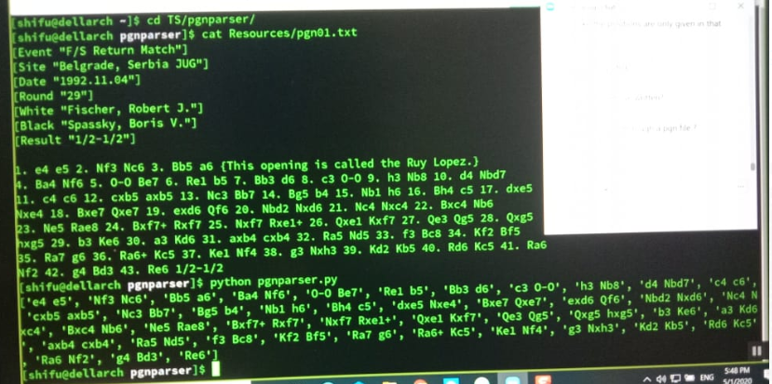

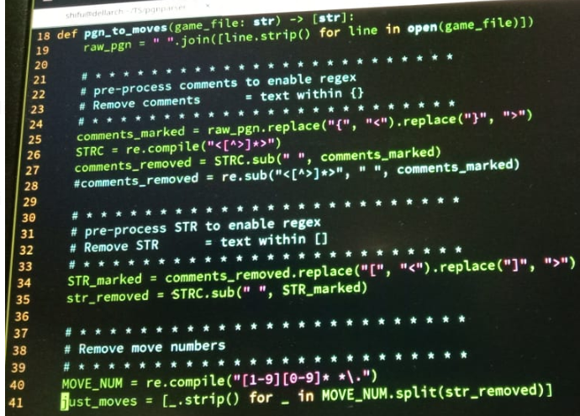

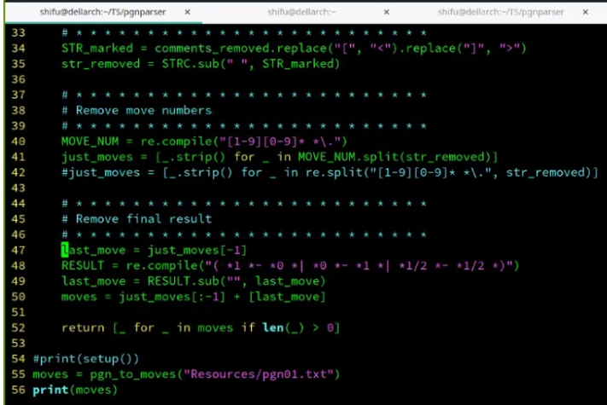

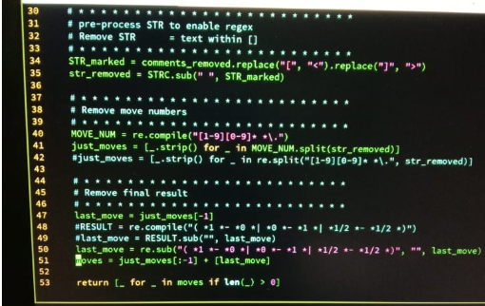

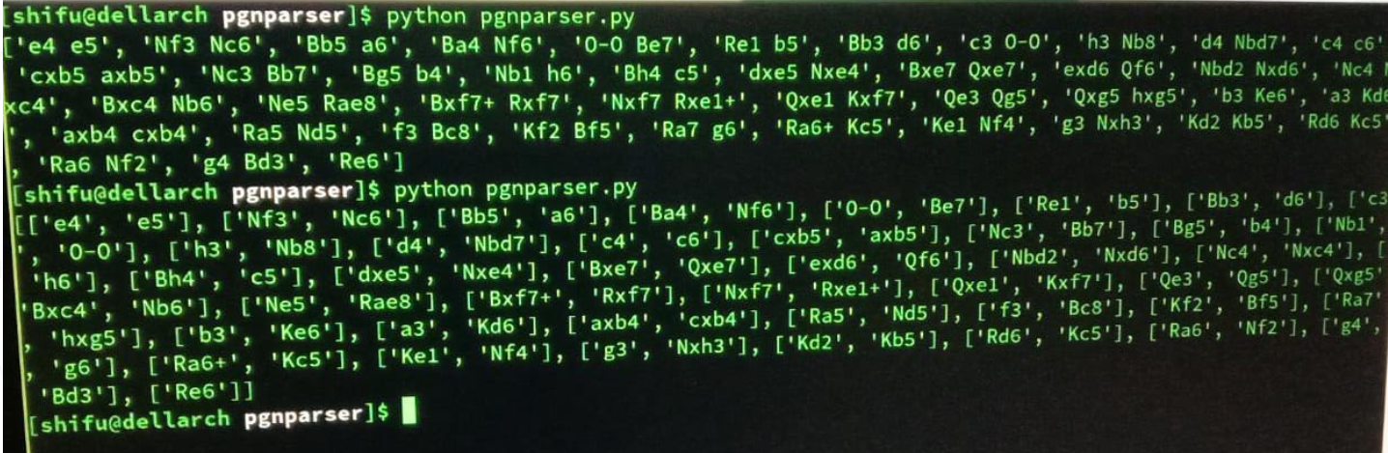

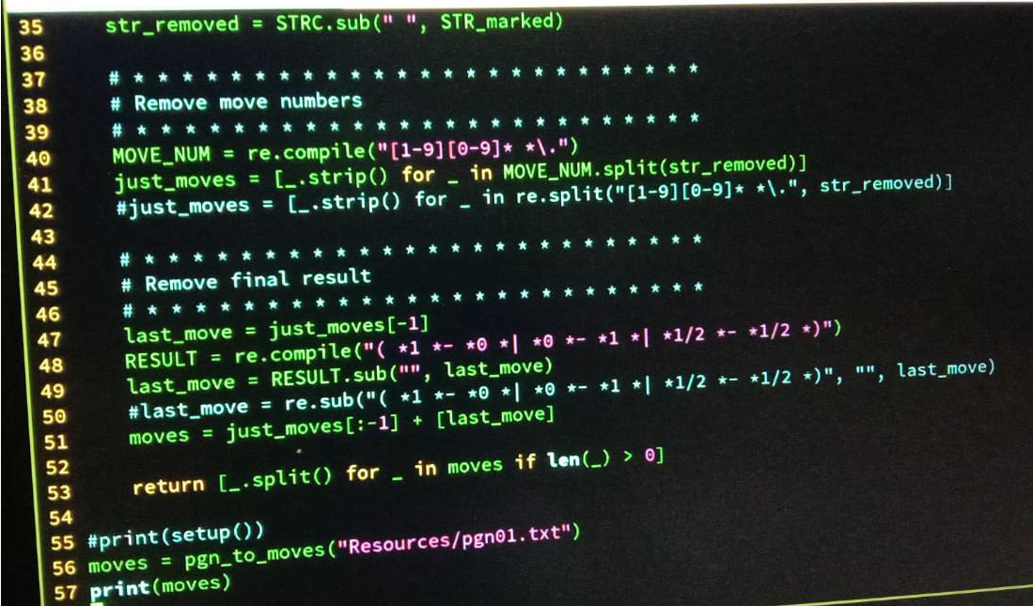

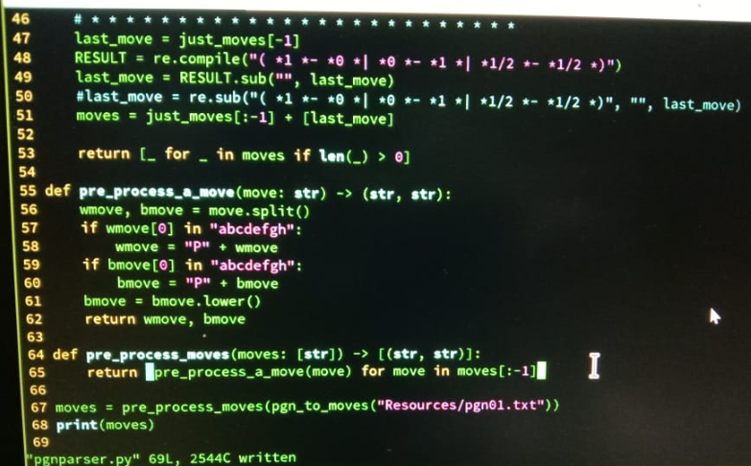

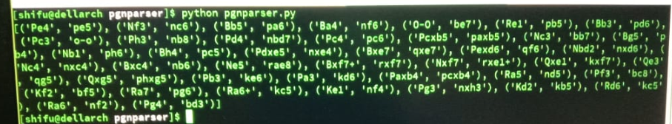

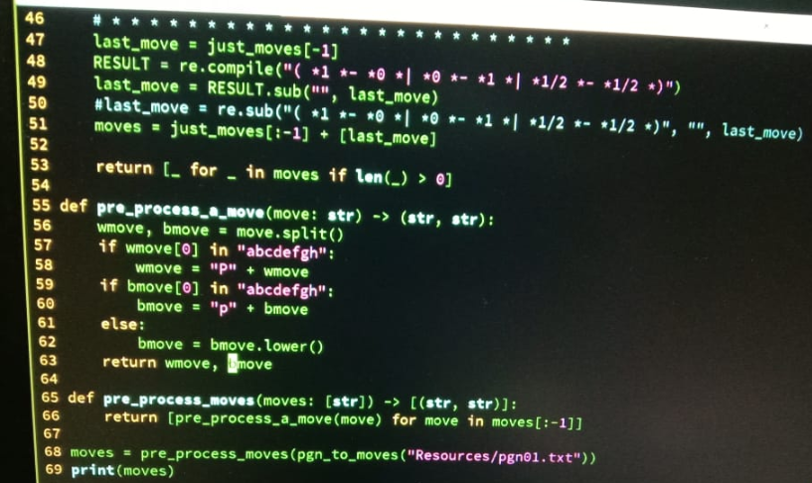

Valid King move, if the piece moves from (X1, Y1) to (X2, Y2), the move is valid if and only if |X2-X1|<=1 and |Y2-Y1|<=1.

Valid Bishop move, if the piece moves from (X1, Y1) to (X2, Y2), the move is valid if and only if |X2-X1|=|Y2-Y1|.

Valid Rook move, if the piece moves from (X1, Y1) to (X2, Y2), the move is valid if and only if X2=X1 or Y2=Y1.

Valid Queen move, a queen's move is valid if it is either a valid bishop or rook move.

Valid Knight move, if the piece moves from (X1, Y1) to (X2, Y2), the move is valid if and only if (|X2-X1|=1 and |Y2-Y1|=2) or (|X2-X1|=2 and |Y2-Y1|=1).

Valid Pawn move, if the piece moves from (X1, Y1) to (X2, Y2), the move is valid if and only if X2=X1 and Y2-Y1=1 (only for a white pawn).